**PMR 3306 - Sistemas Dinâmicos II para Mecatrônica**

**Double Pendulum Project**

**Guilherme Campez Belon - 12550542**

**Matheus Latorre Cavini - 12550494**

**Objectives:** Assess and describe the motion of a double pendulum with concentrated masses, using 3 different approaches: 1- the mathematical formulation of Ordinary Differential Equations, obtained through the application of Lagrangian Mechanics to the model; 2- building up the proposed physical system as close as possible to the ideal model (neglectable masses on the rods, low friction on joints) and analysis of its motion in a tracking software; 3- developing the model on Abaqus software, and running a simulation of motion. Ultimately, compare the results and justify the similarities and differences between them.

**The double pendulum model**

The double pendulum model used in the project consists of two rods, of lengths $l_{1}$ and $l_{2},$ being the first one with one far end attached to a fixed point, and the other one with one far end attached to the first. Besides, both of them are considered to have a point mass on their lowest far ends, respectively $m_{1}$ and $m_{2}.$ The description matches the figure below:

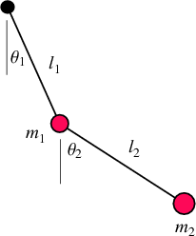

The system has 2 degrees of freedom, since its configuration can be fully described by 2 independent coordinates, which in this case are considered to be the angle of each rod relatively to the vertical axis, named $θ_{1}$ and $θ_{2}.$ Solving the motion of the system means describing the values of $θ_{1}$ and $θ_{2}$ throughout the time.

**1st Approach - Lagrangian Mechanics and ODEs**

The reference system used in the description of coordinates and energies in this approach, as well as in both others, is the one lying on the fixed point to which the first rod is attached. The $x$ coordinate stands for the horizontal axis, pointing right; and $y$ stands for the vertical axis, pointing up.

Beginning with the potential energy, it is given by the sum of the potential energies of both masses, according to the following equations:

$V_{1 }= m_{1}⋅g⋅y_{1}$

$$y_{1}={-l}_{1}⋅cosθ_{1} V_{1 }= {-m}_{1}⋅g⋅l_{1}⋅cosθ_{1}$$

$$V_{2 }= m_{2}⋅g⋅y_{2}$$

$$y_{2}={-l}_{1}⋅cosθ_{1}-l_{2}⋅cosθ_{2}$$

$$V_{2 }= {-m}_{2}⋅g⋅(l_{1}⋅cosθ_{1}+l_{2}⋅cosθ_{2})$$

$$V_{ }= V_{1}+V_{2}= -g⋅\left[(m_{1}+m_{2})⋅l_{1}⋅cosθ_{1}+m_{2}⋅l_{2}⋅cosθ_{2}\right]$$

For the kinetic energy of the masses, mass 1 turns out to be very straight forward, since its velocity is simple given by $v_{1}= l_{1}⋅\dot{θ_{1}}.$ On the other side, for mass 2, the calculation involves the relation between the angular velocity of its own rod along with the coupled velocity from the first rod. Its velocity is then given by:

$${v_{2}}^{2} =(\dot{x_{1}}+\dot{x_{2}})^{2} + (\dot{y_{1}}+\dot{y_{2}})^{2}$$

$${v_{2}}^{2}= ({\dot{θ}}_{1}l_{1}cosθ_{1}+ {\dot{θ}}_{2}l_{2}cosθ_{2})^{2}+ ({\dot{θ}}_{1}l_{1}sinθ_{1}+ {\dot{θ}}_{2}l_{2}sinθ_{2})$$

${v_{2}}^{2}={{\dot{θ}}_{1}}^{2}{l_{1}}^{2}\cos^{2}θ_{1}+ 2 {\dot{θ}}_{1}{\dot{θ}}_{2}l_{1}l_{2}cosθ_{1}cosθ_{2} +{{\dot{θ}}_{2}}^{2}{l_{2}}^{2}\cos^{2}θ_{2}+$

$${{\dot{θ}}_{1}}^{2}{l_{1}}^{2}\sin^{2}θ_{1}+ 2 {\dot{θ}}_{1}{\dot{θ}}_{2}l_{1}l_{2}sinθ_{1}sinθ_{2} +{{\dot{θ}}_{2}}^{2}{l_{2}}^{2}\sin^{2}θ_{2}$$

$${v_{2}}^{2}={{\dot{θ}}_{1}}^{2}{l_{1}}^{2}+ {{\dot{θ}}_{2}}^{2}{l_{2}}^{2}+2 {\dot{θ}}_{1}{\dot{θ}}_{2}l_{1}l_{2}cos(θ_{1}-θ_{2})$$

Thus, the complete expression for the kinetic energy of the system is:

$$T =\frac{1}{2}m_{1}{{\dot{θ}}_{1}}^{2}{l_{1}}^{2}+ \frac{1}{2}m_{2}⋅\left[{v_{2}}^{2}={{\dot{θ}}_{1}}^{2}{l_{1}}^{2}+ {{\dot{θ}}_{2}}^{2}{l_{2}}^{2}+2 {\dot{θ}}_{1}{\dot{θ}}_{2}l_{1}l_{2}cos(θ_{1}-θ_{2})\right]$$

Computing the Lagrangian of the system, then, gives us the following:

$$L = T-V=\frac{1}{2}m_{1}{{\dot{θ}}_{1}}^{2}{l_{1}}^{2}+ \frac{1}{2}m_{2}⋅\left[{v_{2}}^{2}={{\dot{θ}}_{1}}^{2}{l_{1}}^{2}+ {{\dot{θ}}_{2}}^{2}{l_{2}}^{2}+2 {\dot{θ}}_{1}{\dot{θ}}_{2}l_{1}l_{2}cos(θ_{1}-θ_{2})\right]+$$

$$+g⋅\left[(m_{1}+m_{2})⋅l_{1}⋅cosθ_{1}+m_{2}⋅l_{2}⋅cosθ_{2}\right]$$

Using this expression we may derive the differential equations relative to each of the independent coordinates as follows:

$$\frac{d}{dt}\left(\frac{∂L}{∂\dot{θ_{1}}}\right)- \frac{∂L}{∂θ_{1}}=0$$

$$(m_{1}+m_{2})l_{1}{\ddot{θ}}_{1}+m_{2}l_{2}{\ddot{θ}}_{2}cos(θ_{1}-θ_{2})+m_{2}l_{2}\dot{{{\dot{θ}}_{2}}^{2}sin(θ_{1}- θ_{2})+g(m_{1}+m_{2})sinθ_{1}=0}$$

$$\frac{d}{dt}\left(\frac{∂L}{∂{\dot{θ}}_{2}}\right)- \frac{∂L}{∂θ_{2}}=0$$

$$m_{2}l_{2} {\ddot{θ}}_{2}+m_{2}l_{1}{\ddot{θ}}_{1}cos(θ_{1}-θ_{2})-m_{2}l_{1}{{\dot{θ}}_{1}}^{2}sin(θ_{1}-θ_{2})+{gm}_{2}sinθ_{2}=0$$

Manipulating the system of equations for ${\ddot{θ}}_{1}$ and ${\ddot{θ}}_{2}$ gives the format:

$${\ddot{θ}}_{1}= \frac{-sin(θ_{1}- θ_{2})⋅[m_{2}l_{2}{{\dot{θ}}_{2}}^{2}+m_{2}l_{1}{{\dot{θ}}_{1}}^{2}cos(θ_{1}-θ_{2})]-g[(m_{1}+m_{2})sinθ_{1}-m_{2}sinθ_{2}cos(θ_{1}-θ_{2})]}{l_{1}[m_{1}+m_{2}\sin^{2} (θ_{1}- {θ_{2})]}_{}}$$

$${\ddot{θ}}_{2}= \frac{sin(θ_{1}-θ_{2})[(m_{1}+m_{2})l_{1}{{\dot{θ}}_{1}}^{2}+m_{2}l_{2}{{\dot{θ}}_{2}}^{2}cos(θ_{1}- θ_{2})]+ g[(m_{1}+m_{2})[sinθ_{1}cos(θ_{1}-θ_{2})-sinθ_{2}]]}{l_{2}[m_{1}+m_{2}\sin^{2}(θ_{1}- θ_{2})]}$$

The equations obtained are too complex to be solved by hand. Therefore, they were solved via the code below, in Octave software, using the parameters for masses, lengths and initial conditions as in the built physical system (more about them on next section) and the following definitions:

$x_{1}= θ_{1} x_{2}= {\dot{θ}}_{1} x_{3}= θ_{2} x_{4}= {\dot{θ}}_{2}$ 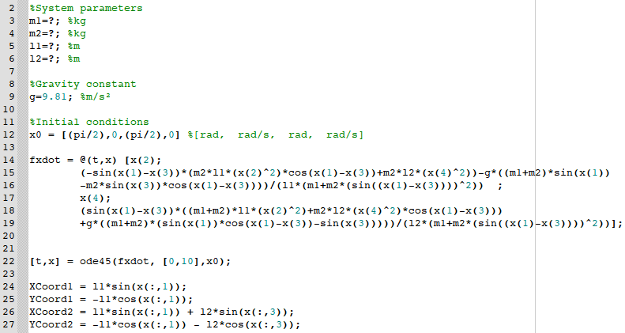

This code solves the ODE systems and outputs the angles $θ_{1}, θ_{2}$ of the rods throughout the time. The angles are then used to calculate the cartesian coordinates of each mass, which will be used to assess the pendulum motion in the results.

**2nd Approach - Building Up a Physical Double Pendulum**

The Physical model of the double pendulum developed for this assignment used simple materials such as toy’s bearings to simulate the masses and allow the rolling system, along with medium density fiberboard to create the rods.

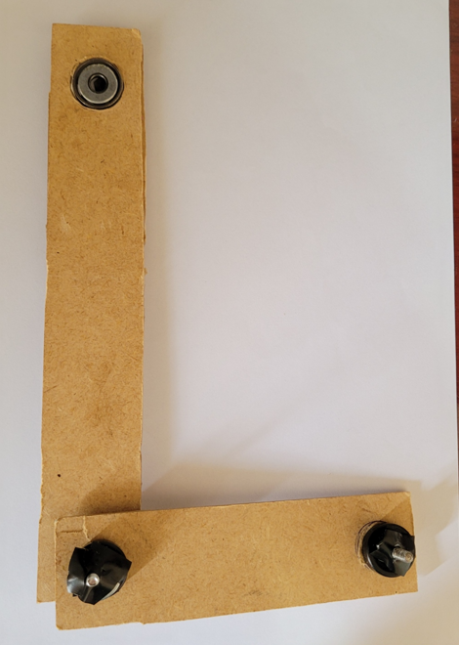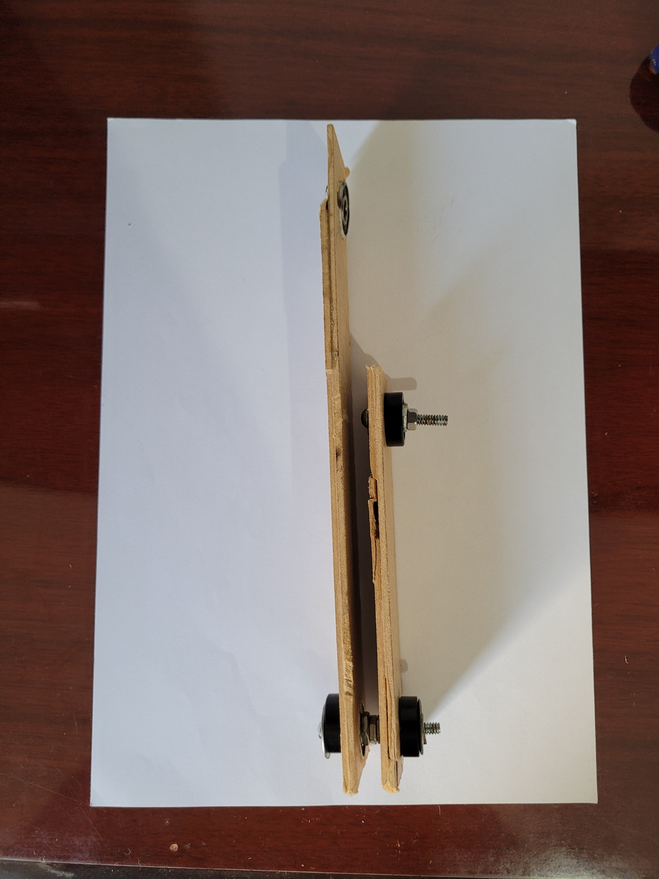

The bearings used in this experiment had an external and internal diameter of 22 mm and 8 mm respectively, and a thickness of 7 mm. In addition, it weighs around 12 grams. Two bearings were used in this experiment: one to attach the bigger rod to the base, and the second to link the smaller one to the bigger one.

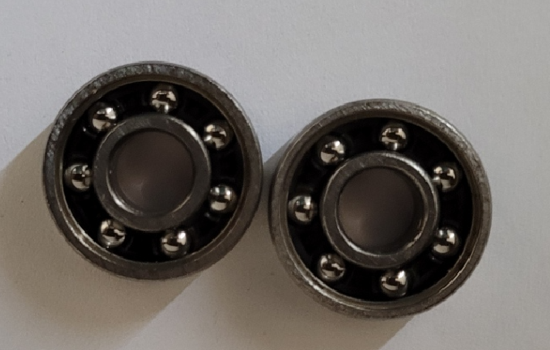

The rods used were crafted using a 3mm MDF. The dimensions chosen had sought to consider a distribution of the mass around the system origin that would result in great captures of the physical model. The width used was 4 cm and the height varied according to the rod. For the first and bigger one, the height was 25 cm; whereas in the second, it was 15 cm. Given the density of the MDF of $0.6g/cm^{3}$, we can find the mass of each rod:

$$First rod: 0.6 * (0.3*4*25) = 18 g$$

$$Second rod: 0.6 * (0.3*4*15) = 10.8 g$$

Some holes were carved in the wood to allow the masses to be fixed, but the mass of the MDF removed was considered negligible. In the first rod, a 22 mm puncture was made with a center distancing 3 cm to the top part of the wood. In addition, another 22 mm hole was created, but this time with a center 2 cm away from the bottom of the rod. They were both used to place the bearings properly.

In the second rod, a 3 mm puncture distancing 15 mm from the top was created to allow the passing of a screw through the wood, which would be later used to unite both rods. Another one of 15 mm distancing 15 mm from the bottom was created. This one was made to allocate the second mass.

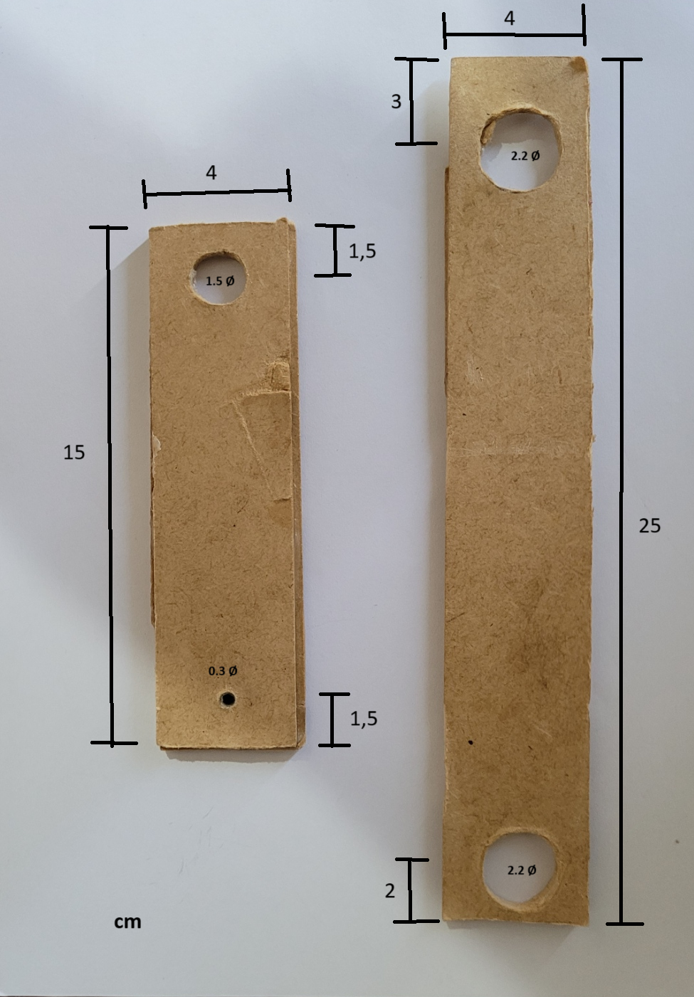

It is important to point out that the process of uniting both woods was made using a 5 cm length screw (8 grams) and three bolts of 2 grams each. These, in addition to the mass of the bearing, two 1 gram washers and two other masses of 12 grams each, creates an amount of 52 grams for the mass 1.

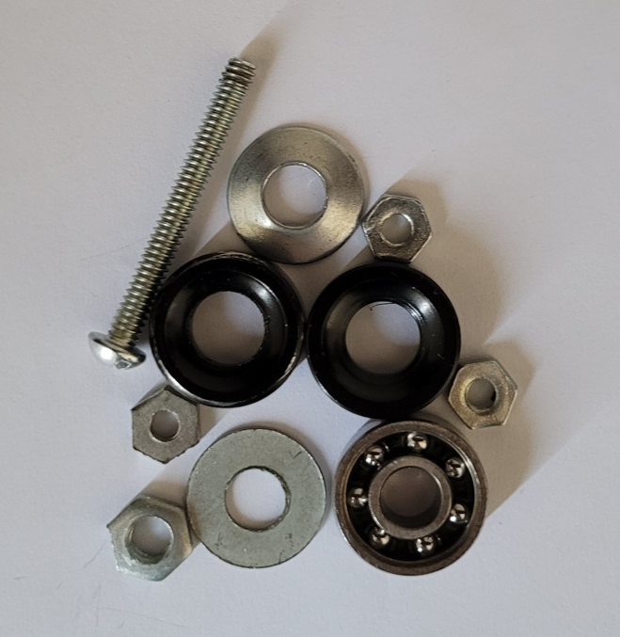

For the second mass, a brass weight of around 8 grams was attached at the end of the second rod, along with another 12 grams mass, a 6 grams 3 centimeters screw united with two 2 grams bolts. All of these parts are used to create the 30 grams mass 2.

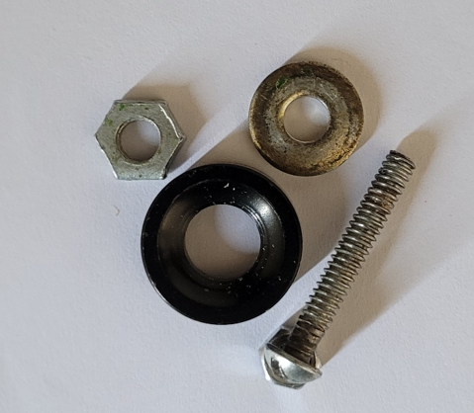

**3rd Approach - Finite Elements Simulation on Abaqus**

The model of the double pendulum developed in Abaqus consists primarily of 3 points, created on the “Part” tab: 1 for the fixed point to which rod 1 is attached, with null mass; and 1 for each concentrated mass in the far end of the rod, to which the value of mass corresponding to the physical system created was assigned.

On the “Assembly” tab, the 3 points were introduced into the model and placed on the coordinates corresponding to the initial conditions of the system. A step of 10 seconds was created to run the simulation.

Lastly, two interactions of type “wire” were added to the model, linking the mass 1 to the fixed point and mass 2 to mass 2 (representing the rods); the fixed point was pinned up in place with a boundary condition, and gravity was introduced.

The figure below shows the complete model, ready for running the simulation which will be further explored on the results

.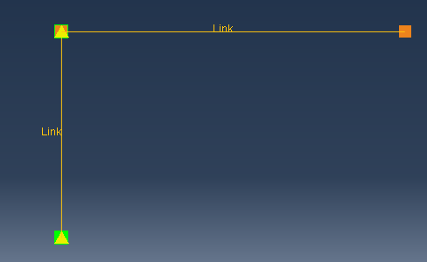

**Results and Discussion**

In order to assess the motion of the double pendulum in the 3 models developed (Lagrangean mechanics, physical and simulation), two sets of initial conditions were considered to compare the results:

* The 1st one in which rod 1 was positioned in a 90º angle relative to the vertical axis, and rod 2 in a 0º angle, as the following images:

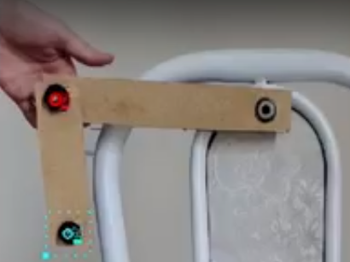

* The 2nd one, which occurs around the time of 11 seconds in the motion resulting from the first initial conditions, where both rods describe a 13º angle with the vertical axis. This condition was used in order to assess a better behaved motion.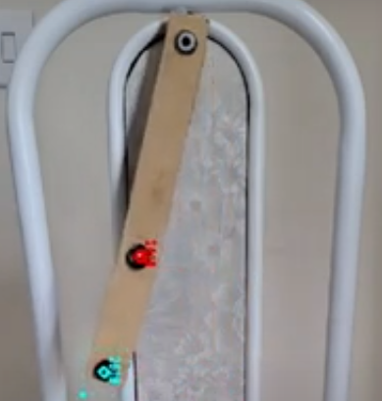

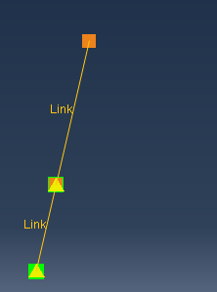

Besides, the lengths and masses of mathematical and simulation model were assigned in order to correspond to the built pendulum, they being $l_{1}=0.2m; l_{2}=0.12m; m_{1}=0.052kg; m_{2}= 0.03kg.$

For the physical double pendulum model developed, the results were obtained by recording the motion of the object for more than 30 seconds, a time big enough ro abstract most of the data necessary, even though 10 seconds were already enough for most of the conclusions. The filming was portrayed in a frame rate of 240 frames per second, which later helped to better track the position of each mass.

For this process, the software Tracker was used. The process began by defining each initial position of the masses that would be later tracked. Also, the cartesian axes were displaced with its origin set in the first bearing, and the dimensions were obtained using the 20 cm rod as a reference.

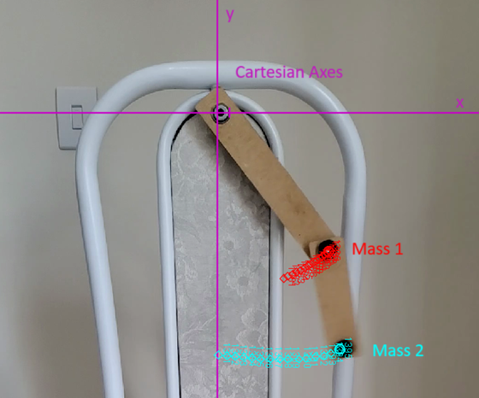

Once the positions were determined, they were transferred to a sheet file where they could be used to develop the analysys.

For the 1st approach, via Lagrange Mechanics, the code presented before was used to solve the coordinates of the pendulum along the time. Besides, a code was used to generate the animation of motion which will be further included in the videos attached to this report. Lastly, for the 3rd approach, the graphs of the coordinates are automatically generated by Abaqus.

To analyze the results, **the graphs of the X coordinate of the 2nd mass were chosen to represent the motion.** The other graphs for the other coordinates are included as an appendix at the end of this document. The results for each initial condition are presented below.

***Condition 1: 90º and 0º angles for rods 1 and 2.***

Octave graph

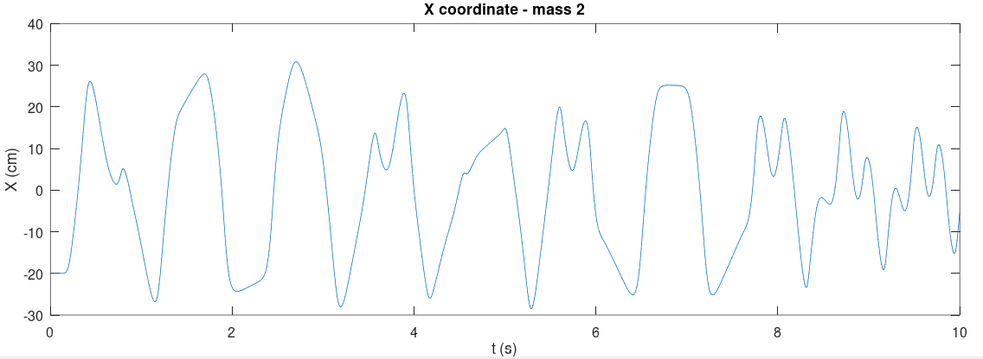

Tracker graph

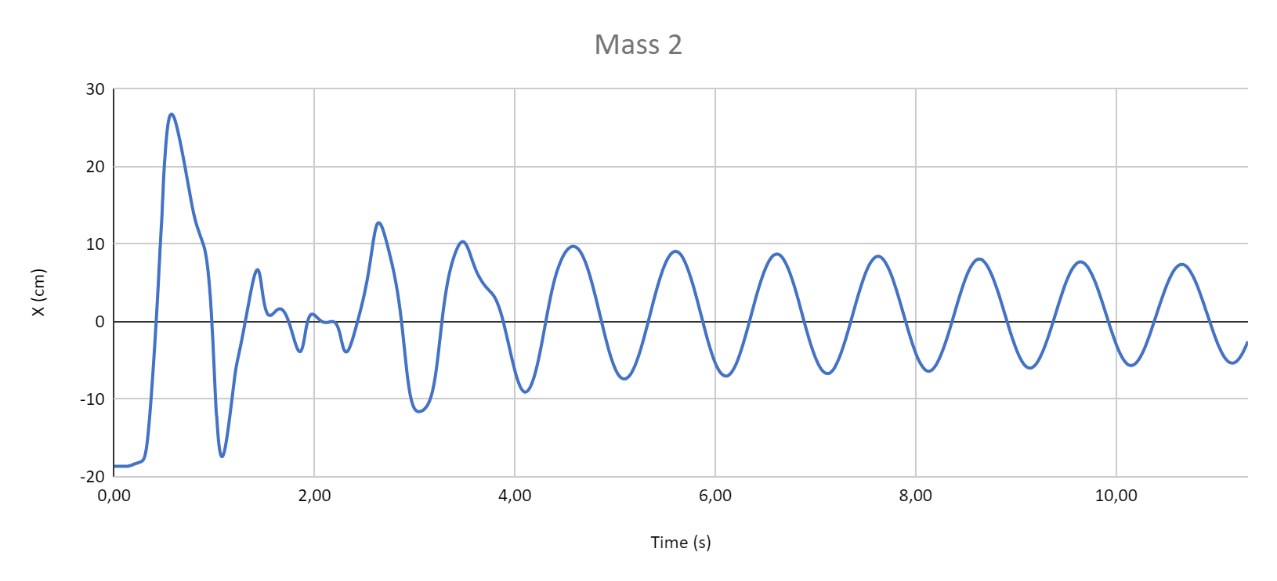

Abaqus graph

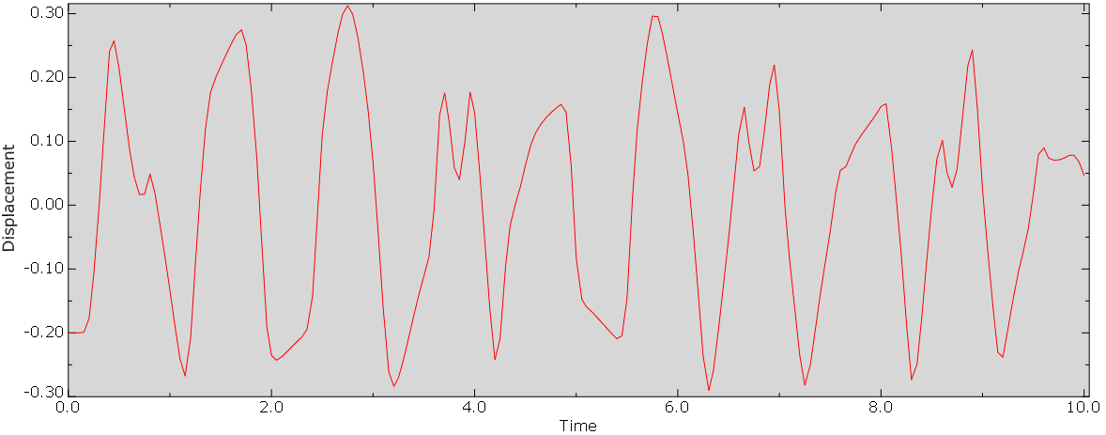

Through the graphs presented, it is possible to see that **approaches 1 and 3 (lagrangian and Abaqus) match considerably well** until the 5 seconds time, since they both disconsider friction and rod masses. For times further than 5 seconds, the solutions start to diverge, probably because of small differences in the mathematical tools used by each software to solve the problem.

**Approach 2, otherwise, matches well with both others only until about 1 second**. This happens because in the simulated models mass 2 describes a loop at around 1 second (video attached), while in the real pendulum the loop is not completed due to the influence of friction. So, for times further than 1 second, the graphs are unmatched.

***Condition 2: 13º and 13º angles for rods 1 and 2.***

Octave graph

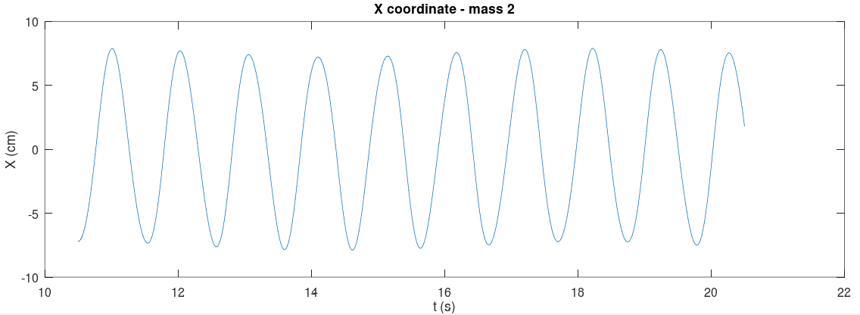

Tracker Graph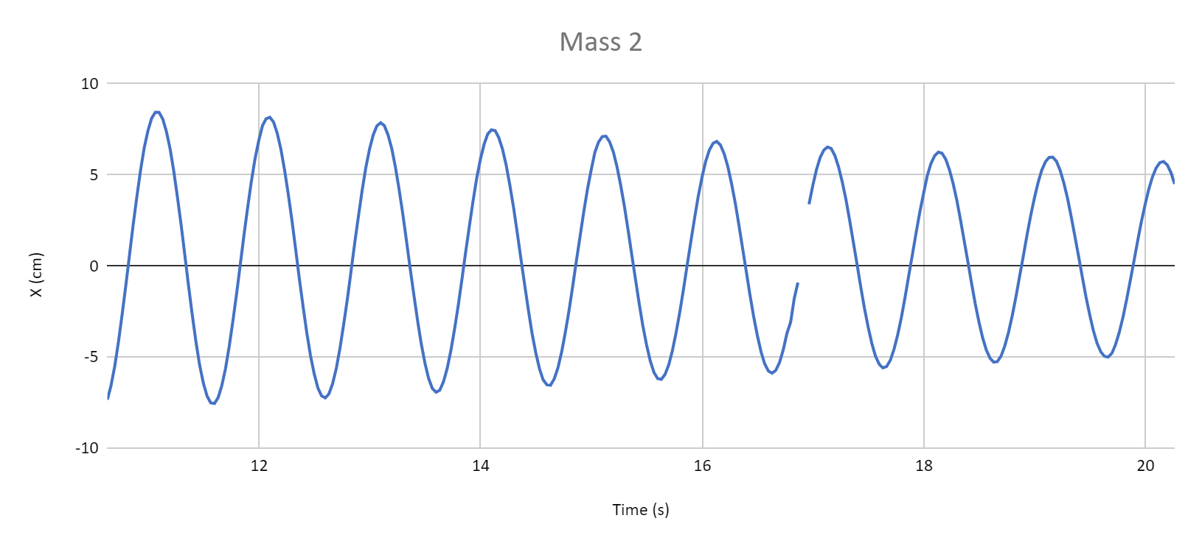

Abaqus Graph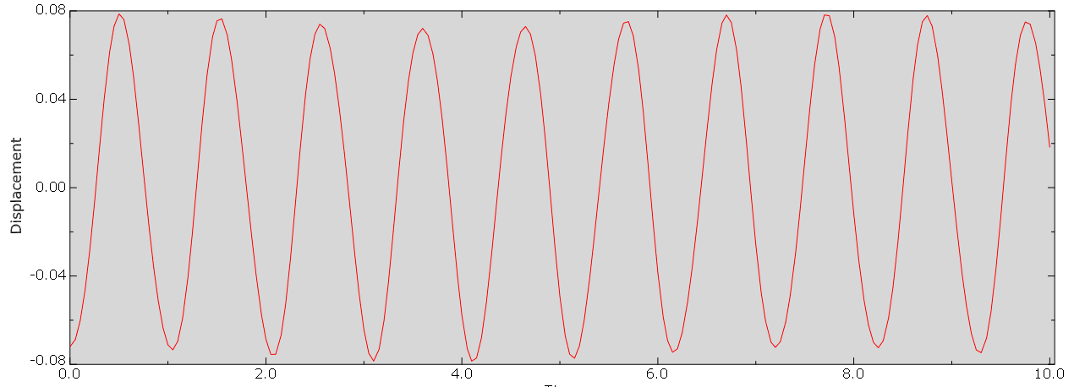

For these initial conditions, it is evident that the motion of the pendulum is a lot more well behaved than in the first one. This, due to the small range of motion and energies involved. In this case **the 3 different approaches match perfectly,** mainly, and most importantly, when it comes to the number of oscillations in the given period of time (10 seconds after the initial instant of 11 seconds).

The only difference between the real pendulum (approach 2) and the simulated ones is that the range of motion in the physical system suffers an exponential decay, due to the presence of friction in the joint, which is neglected on simulations.

The analysis of the motion in this case allows us to determine the natural frequency of the system, which is about 0.96Hz.

**Final Comments**

The development of this project introduced a practical view on how two different kinds of simulation - numerical and finite element analysis - may perform as a tool to assess physical systems.

The simulations performed quite effectively for the cases in which the chaotic nature of the motion of a double pendulum does not affect the solutions too much. On the other hand, for the cases where chaos plays an important role, such as loops, the simulations diverged from the real model because even the slightest presence of friction was enough to completely change the nature of motion.

**References**

[1] WOLFRAM RESEARCH. Double Pendulum. Available at:

https://scienceworld.wolfram.com/physics/DoublePendulum.html. Visited: 25 ago. 2023.

[2] BADEN, Drew. Double Pendulum. 2019. Available at:

http://www.physics.umd.edu/hep/drew/numerical_integration/pendulum2.html. Visited: 25 ago.

2023.

**Appendix - Graphs for other coordinates (X and Y for mass 1 and Y for mass 2)**

*Condition 1*

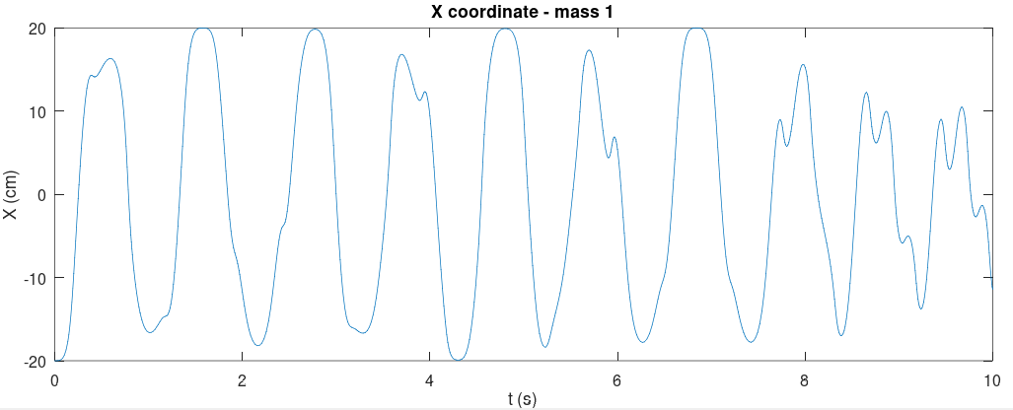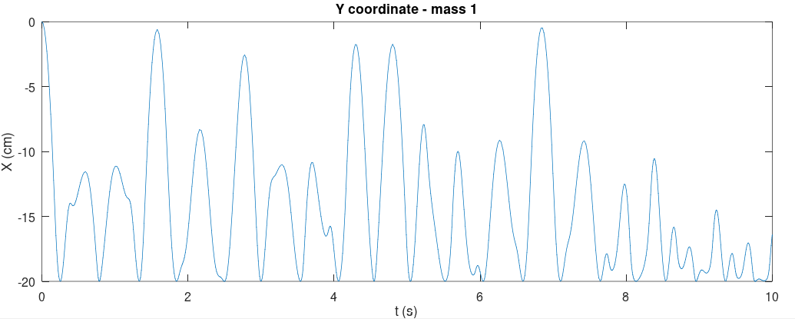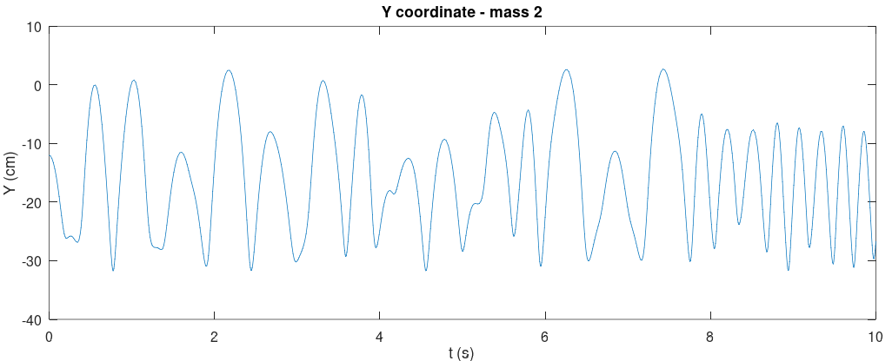

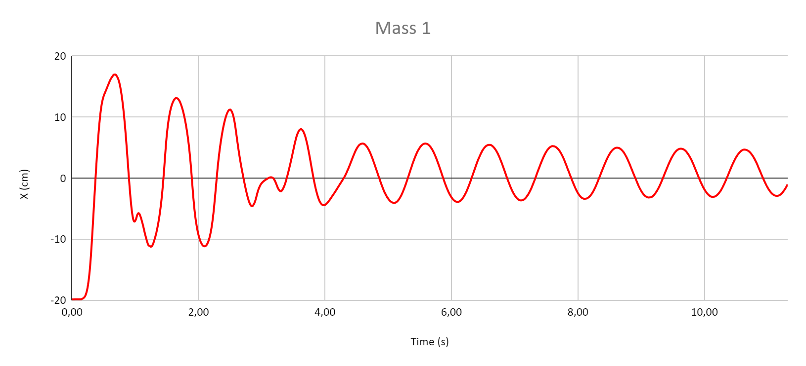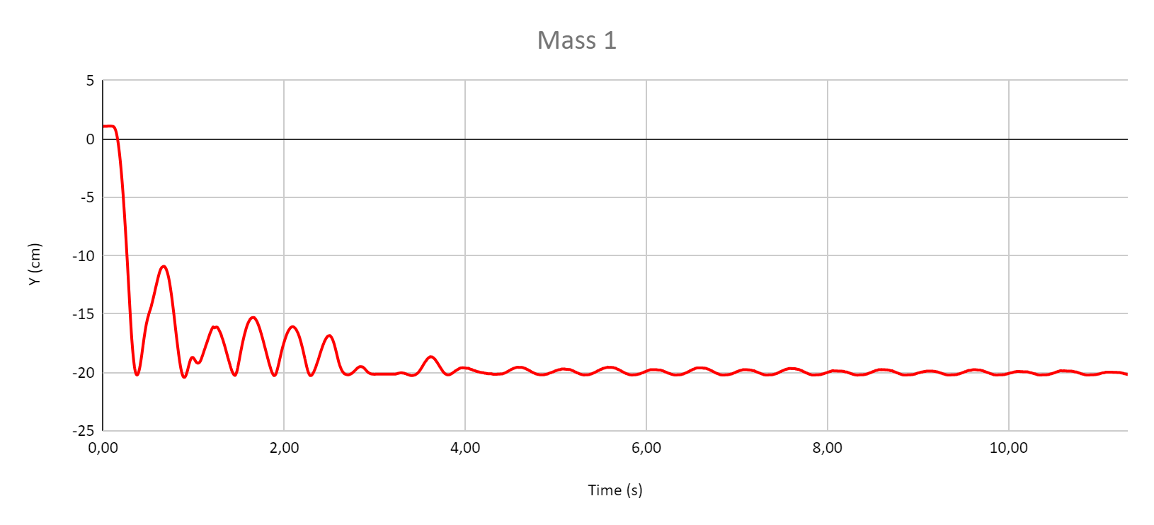

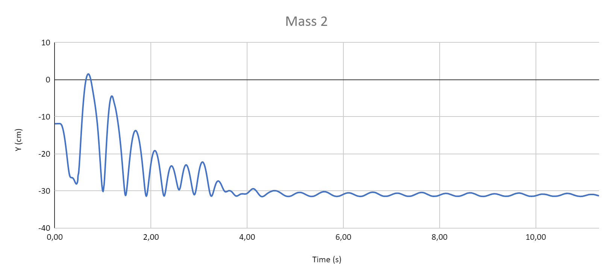

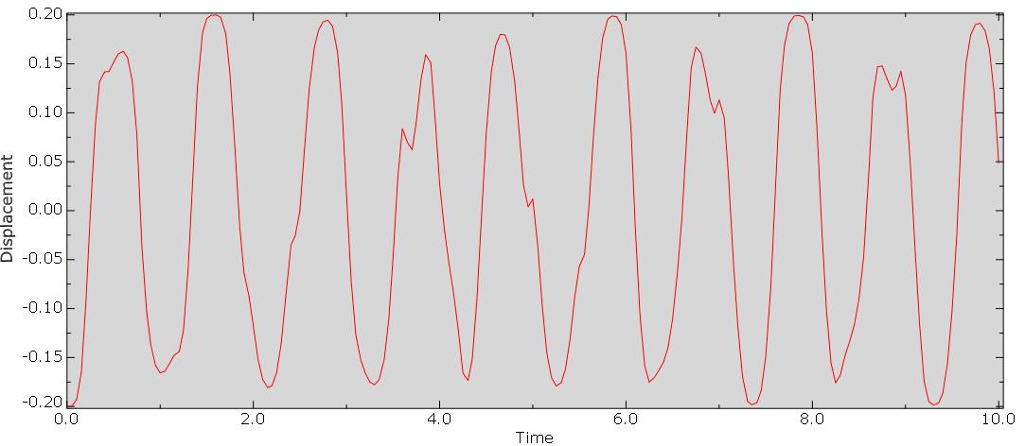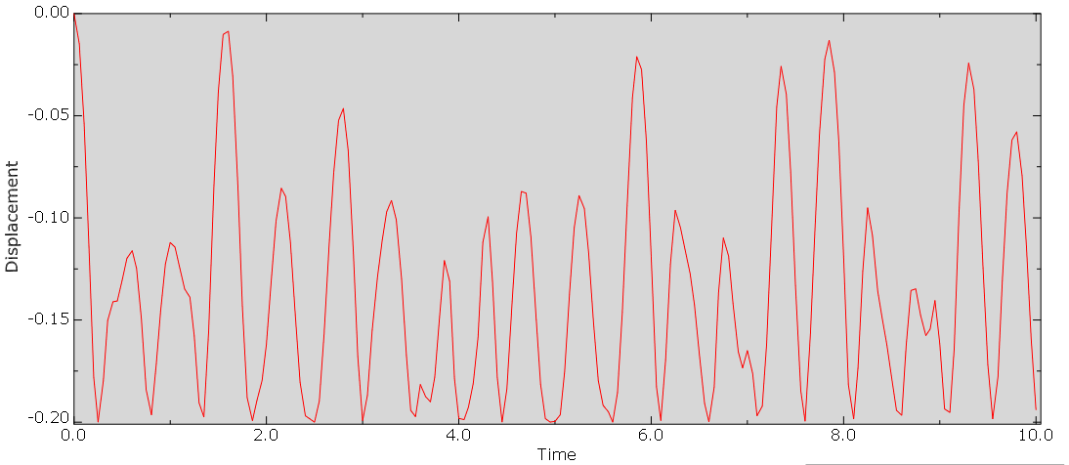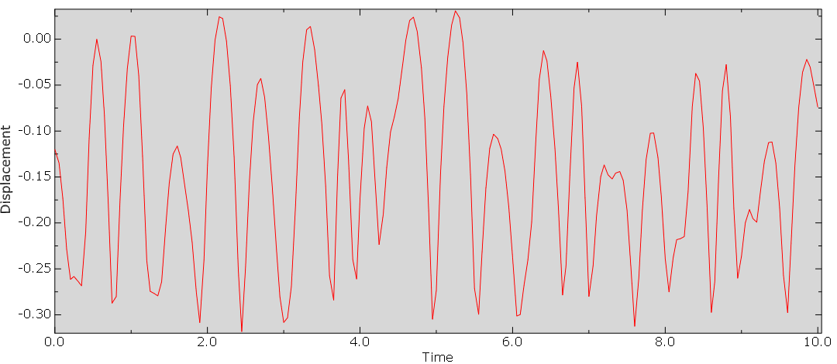

*Condition 2*

